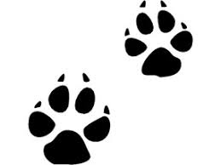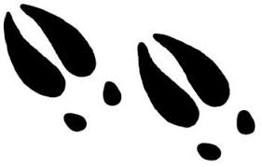
ANIMAL TRACKING
Who Lives Here Now?
What is Animal Tracking and who uses it? ___________________________________________________________________________________________

List some types of wildlife you would find at Camp JOLT:
1. | 2. | 3.
4. | 5. | 6.

“Sign tracking” is one way to look for an animal. What “signs” or clues, beside a FOOTPRINT, would be another indication of an animal?
1. | 2. | 3.

What can scientists determine about an organism based upon the clues left behind? (For example, scat could indicate what an animal ate, and webbed feet might show what environment they live.)
______________________________________________________________________________________________________________________________________________________________________________________

What 4 things make a Habitat? (Circle 4)
Temperature Food Environment Soil Woods Gravity
Water Health Scat House Space Shelter

Each animal and plant in nature has its own “niche” or special role, to make natural communities work and stay healthy. Match the following animals with their niche:
- Bees ______ Decomposer
- Squirrel ______ Population Control
- Daddy Long Legs ______ Wetland Creator
- Beaver ______ Pollinator
- Woodpecker ______ Seed Spreader

Choose a set of animal tracks to Study. Sketch a picture of your animal track.

Length of Track ________________
Width of Track ________________
Depth of Track ________________

Animal Identification _____________________

Where was Track found? __________________

|I|I|I|I|I|I|I|I|I|I|I|I|I|I|I|I|I|I|I|I|I|I|I|I|I|I|I|I|I|I|I|I|I|I|I|I|I|I|I|I|I|I|I|I|I|I|I|I|I|I|I|I|I|I|I
0| 1| 2| 3| 4| 5| 6|

