Owl Pellets

A ________________________ is a bird of prey that catches its food with its talons.

What are some other types of raptors? ____________________________________________________

What adaptations do Raptors have to hunt their prey?
_____________________ _____________________ ______________________

Name a few animals that fit into this Food Web:
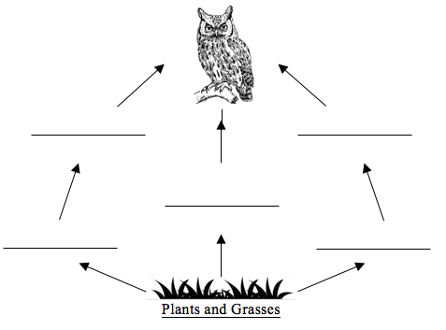
Hypothesis: Based on the looks of your owl pellet what kind of animal remains do you think you will find? ___________________________________________________________________________________
Draw and identify the bones that you found in your owl pellet in the box below.

Conclusion: Do the results support your hypothesis? _________________________________________
If no, what animal did the remains come from? ______________________________________________

|I|I|I|I|I|I|I|I|I|I|I|I|I|I|I|I|I|I|I|I|I|I|I|I|I|I|I|I|I|I|I|I|I|I|I|I|I|I|I|I|I|I|I|I|I|I|I|I|I|I|I|I|I|I|
0| 1| 2| 3| 4| 5| 6|

